***Module 4 – Database***

1. **What is RDBMS**

* RDBMS stands for **Relational Database Management System**.
* It is a type of database management system (DBMS) that stores data in a structured format, using rows and columns in tables, which are related to each other based on certain relationships.
* The "relational" part of the name comes from the concept of using tables (also called relations) to represent and manage data.
* **Key features of an RDBMS include:**
* **Tables**: Data is stored in tables, which consist of rows and columns.
* **Relationships**: Tables can be related to each other through keys (primary keys and foreign keys).
* **SQL (Structured Query Language)**: RDBMS systems use SQL for querying and managing the database.
* **ACID Properties**: RDBMS systems typically ensure data integrity and reliability through ACID (Atomicity, Consistency, Isolation, Durability) properties.
* **Normalization**: Data is often organized and structured in a way that reduces redundancy and ensures consistency.

1. **What is SQL**

* It is stands for structured query language.
* It is a standard programming language used to manage and manipulate relational databases.
* SQL allows you to perform various operations on the data stored in a database, such as:
* **Querying**: Retrieving data from one or more tables using SELECT.
* **Inserting**: Adding new records into tables with INSERT.
* **Updating**: Modifying existing records with UPDATE.
* **Deleting**: Removing records from tables using DELETE.
* **Creating and modifying structures**: Creating or altering tables, indexes, and other database objects using CREATE, ALTER, and DROP

1. **Write SQL Commands**

* **1. CREATE TABLE:-**

CREATE TABLE sellers (

sellersID INT(11) PRIMARY KEY AUTO INCREMENT,

Name VARCHAR(50),

Contact bigint(11),

Address VARCHAR (255),

Email VARCHAR(255),

Password VARCHAR(255)

);

* 2.  **TO INSERT DATA:-**

INSERT INTO sellers (

Name, Contact, Address, Email, Password)

VALUES (

‘HETAL’, ‘9033178002’,’NADIAD’,’hetal@gmail.com’,’user@123’)

* **3. TO UPDATE:-**

UPDATE sellers set contact=9876500000,

Address=’AHMEDABAD’ WHERE ID=1;

* **4. TO DELETE DATA:-**

DELETE FROM sellers WHERE ID=1;

* **5. TO ADD COLUMN:- (FOR STRUCTURAL CHANGES)**

ALTER TABLE sellers add column DOB date;

* **6. TO SELECT DATA :-**

SELECT * from sellers WHERE ID=1;

SELECT name, contact from sellers WHERE ID=1;

* **7. DROP TABLE (use to delete entire table from database):-**

DROP TABLE sellers;

1. **What is join?**

* In SQL, a **JOIN** is used to combine rows from two or more tables based on a related column between them.
* When working with relational databases, tables often store related data, and the JOIN operation helps link these tables to retrieve meaningful information.

1. **Write type of joins.**There are five types of joins are as under:-

* Inner join (or JOIN)
* Left join
* Right join
* Full join
* Natural join

1. **How Many constraint and describes it self**

* **constraints** are rules that are applied to the columns of a table to enforce data integrity, ensure the correctness of data, and maintain relationships between tables.
* There are several types of constraints, and each serves a specific purpose.

1. **PRIMARY KEY:-** Ensures that each record in the table is unique and that the column and it cannot be NULL.
2. FOREIGN KEY
3. UNIQUE
4. NOT NULL
5. CHECK
6. **Difference between RDBMS vs DBMS**

|  |  |  |
| --- | --- | --- |
| **FEATURE** | **DBMS** | **RDBMS** |
| Definition | A DBMS is a software system that manages databases, allowing data storage, retrieval, and manipulation. | An RDBMS is a type of DBMS that stores data in a structured format using rows and columns in tables. |
| Data Storage | Data can be stored in any format (flat files, hierarchical, etc.). | Data is stored in a tabular (relational) format, with rows and columns in tables. |
| Structure | Data can be stored without a strict structure. | Data is organized into tables with predefined relationships between them. |
| Relationships | Does not support relationships between data. | Supports relationships between tables (using foreign keys). |
| Normalization | No normalization (data redundancy may occur). | Data is usually normalized (reducing redundancy and improving integrity). |

1. **What is an SQL alias?**

* An **SQL alias** is a temporary name that you can assign to a table or column for the duration of a query.
* Aliases are often used to make SQL queries easier to read and write, especially when dealing with long table names or complex expressions.
* Aliases are not permanent and only exist during the execution of a query.

1. **Write a query to create the table in Structured Query Language.**

* CREATE TABLE sellers (

sellersID INT(11) PRIMARY KEY AUTO INCREMENT,

Name VARCHAR(50),

Contact bigint(11),

Address VARCHAR (255),

Email VARCHAR(255),

Password VARCHAR(255)

);

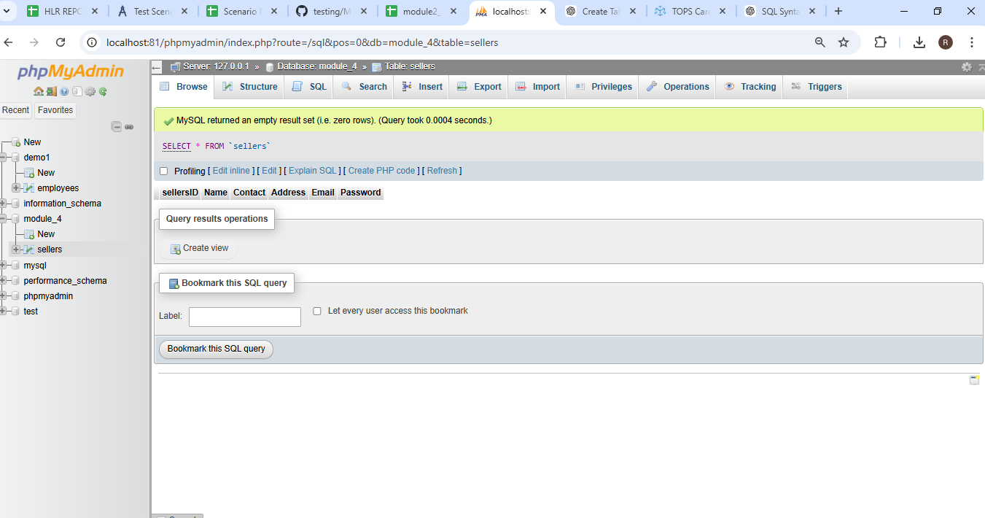

1. **Write a query to insert data into table.**

* INSERT INTO sellers ( Name, Contact, Address, Email, Password)

VALUES ( ‘HETAL’, ‘9033178002’,’NADIAD’,’hetal@gmail.com’,’user@123’),

( ‘KALYANI’, ‘9890876576,’RAJKOT,’kalyani@gmail.com’,’user@456’),

( ‘RAJA’, ‘9987654098,’SURENDRANAGAR,’raja@gmail.com’,’user@789’),

( ‘RAVI’, ‘9876544322,’NADIAD’,’ravi@gmail.com’,’user@999’);

1. **Write a query to update data into table with validations.**

* UPDATE sellers set contact=9876500000,

Address=’AHMEDABAD’ WHERE ID=1;

1. **Write a query to delete data from table with validations.**

* DELETE FROM sellers WHERE ID=1;

1. **Write a query to insert new column in existing table.**

* ALTER TABLE sellers add column DOB date;

1. **Write a query to drop table and database.**

* DROP TABLE sellers;
* DROP DATABASE databaseName;

1. **Write a query to find max and min value from table.**

* SELECT

MAX (SALARY) AS MaxSalary,

MIN (SALARY) AS MinSalary

FROM

Sellers;

1. **Create two tables named Seller and Product apply foreign key in product table**
2. **Fetch data from both table using different joins.**
3. **What is API Testing**

* **API Testing** is the process of testing the **Application Programming Interface (API)** to ensure it works as expected.
* APIs are used to allow different software applications to communicate with each other, and testing them is crucial to verify that data is correctly exchanged, the business logic is properly implemented, and the system performs well under various conditions.
* **Key Objectives of API Testing:**

1. Functionality
2. Reliability
3. Performance
4. Security
5. Error Handling
6. Data Integrity.
7. **Types of API Testing**

* There are various types of API testing are as under.

1. **Functional Testing**: Verifying if the API works according to its specifications. This includes checking that the correct response is returned when valid requests are made.
2. **Load Testing**: Testing how the API behaves under stress, such as high traffic or multiple concurrent requests.
3. **Security Testing**: Ensuring the API is secure from unauthorized access and potential vulnerabilities.
4. **Validation Testing**: Ensuring that the API provides the correct data format and that the returned data is accurate.
5. **Error Handling Testing**: Verifying that the API handles errors properly and returns appropriate error codes/messages when needed.
6. **What is Responsive Testing?**

* **Responsive Testing** refers to the process of testing a website or application to ensure it **properly adjusts and functions across various screen sizes and devices**.
* The goal of responsive testing is to verify that the web application provides a seamless and optimal user experience regardless of the device—whether it's a desktop, tablet, or smartphone.
* **KEY AREAS OF RESPONSIVE TESTING.**

1. Layout
2. **Design Consistency**
3. Interactivity
4. Performance
5. Touch & Click Elements
6. **Which types of tools are available for Responsive Testing**

* There are several types of tools available for **Responsive Testing** that help you ensure your website or application works well across various devices and screen sizes.
* Here’s are some of the most common types of tools used for responsive testing:

1. **What is the full form of .ipa, .apk**

* **.ipa**: **iOS App Store Package**  
  It is the file format used for iOS applications (Apple devices like iPhones and iPads). This file contains all the necessary components and resources for an iOS app to run on Apple devices.
* **.apk**: -**Android Package Kit**  
  It is the file format used for Android applications. An APK file contains all the code, resources, assets, and metadata needed for an Android app to be installed and run on Android devices.

1. **How to create step for to open the developer option mode ON?**

* **Developer Options** is a hidden menu on Android devices that provides a set of advanced settings and tools primarily designed for app developers. These options help in debugging, testing, and optimizing apps during development. By enabling Developer Options, users gain access to various system settings and features that are typically not available in the standard user interface.
* **Here are the steps for enabling developer mode on:-**

1. Open **Settings**.
2. Scroll down to **About phone/ About device**.
3. (Tap on version)
4. Tap **Build number** 7 times.(Tap on version)
5. Once enabled, go back to the **Settings** menu, and you'll see **Developer options** at the bottom.